# **Mini Project Report on Sales Performance Dashboard**

**Dashboard:**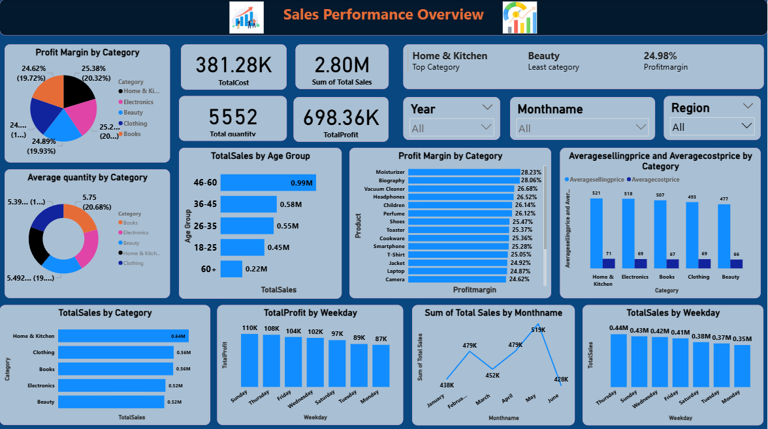

**Project Title**: **Sales Performance Dashboard**

**Submitted By**: **KODAVALLURI DINESH SAI**

**Date: 11/07/2025**

**Batch: Data Analytics(Batch 3)**

**Tools Used**: **Power BI, Excel, DAX**

# 1. Project Objective

The objective of this project is to design and develop an interactive **Sales Performance Dashboard** using Power BI to provide comprehensive insights into key business metrics. This dashboard aims to help stakeholders understand sales trends, customer demographics, product performance, and profitability. By leveraging Power BI’s data modeling, DAX formulas, and visualization features, the project enables:

* Monitoring of total revenue, profit, and cost metrics.
* Identification of top-performing product categories and customer segments.
* Analysis of customer behavior based on age and gender.
* Tracking of monthly and weekly sales trends.
* Comparison of sales and profit margins across different categories.
* Creation of a user-friendly, dynamic interface with filters and drill-down capabilities for better decision-making.

# 2. Data Source

# File Name: EcommerceSalesDataproject.xlsx

# Imported From : Kaggle website

# Sheets/Tables Used: Orders ,Calendar Date tables

# 3. Data Cleaning & Transformation (Power Query Editor)

Steps taken:

* Removed blank/null rows
* Changed data types (Date columns → Date)
* Created calculated columns:  
   • Profit = Sales – Cost  
   • Profit Margin = Profit / Sales

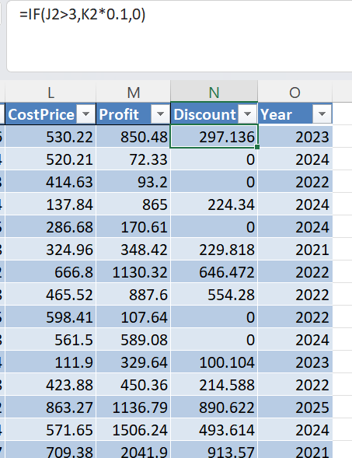

* Renamed columns for clarity (e.g., Order Date, Customer Age,Gender)
* Created custom Age Groups using conditional column:

**Age Group =   
if [Age] >= 18 and [Age] <= 25 then "18-25"  
else if [Age] <= 35 then "26-35"  
else if [Age] <= 45 then "36-45"  
else if [Age] <= 55 then "46-55"  
else "56+"**

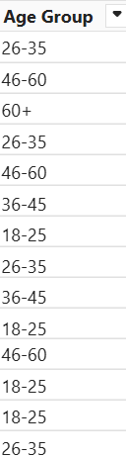

# 4. Data Modeling

* Defined relationships:  
   • Orders[Order Date] → Calendardate[Date]
* Cardinality: Many-to-One
* Cross Filter Direction: Single

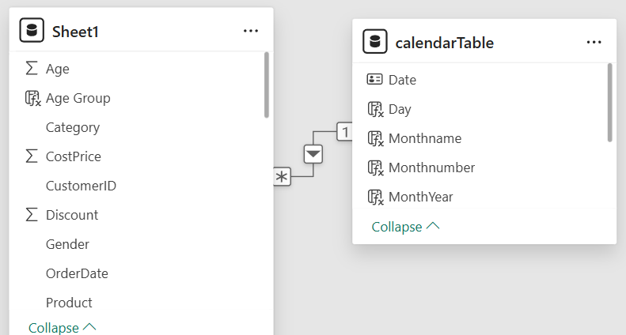

# 5. Measures (DAX)

* Created DAX measures for KPIs:
* Total Sales = SUM(sheet1[Sales])
* Total Cost = sum(Sheet1[CostPrice])
* Total quantity = sum(Sheet1[Quantity])
* Total Profit = SUM(sheet1[Profit])
* Profit Margin = DIVIDE([Total Profit], [Total Sales])
* Average Order Value =Divide(sheet1[Sales],sheet1[total orders])
* Age Group = SWITCH( TRUE(),

Sheet1[Age]>= 18 && Sheet1[Age]<= 25, "18-25"

Sheet1[Age] >= 26 && Sheet1[Age]<= 35, "26-35",

Sheet1[Age]>= 36 && Sheet1[Age] <= 45, "36-45",

Sheet1[Age] >= 46 && Sheet1[Age] <= 60, "46-60",

Sheet1[Age] > 60, "60+",

    "Unknown")

* Previous Year sales = CALCULATE([TotalSales],PREVIOUSYEAR(calendarTable[Date]))
* Previous Quarter sales = CALCULATE([TotalSales],PREVIOUSQUARTER(calendarTable[Date]))
* Previous Month sales = CALCULATE([TotalSales],PREVIOUSMONTH(calendarTable[Date]))
* YOY growth% = DIVIDE([YTD]-[Previousyearsales],[Previousyearsales],0)
* Customer Count = COUNT(Sheet1[CustomerID])

# 6. Visualizations

* Used the following visuals:
* KPI Cards: Total Sales, Total Profit, Profit Margin, Total Quantity, Total Cost
* Clustered Column Chart: Average selling and cost price by Category
* Stacked Column Chart: Total sales by Weekday
* Line Chart: Monthly Sales Trend
* Pie Chart: Profit Margin by Category
* Donut Chart: Average Quantity by Category
* Stacked Bar Chart: Total sales by category
* Clustered Bar Chart: Sales by Gender & Age Group

# 7. Filters and Slicers

* Added:
* Month Filter (Order Date)
* Year Filter (Order Date)
* Region Filter

# 8. Dashboard Design

* Use consistent color themes
* Add chart titles
* Add a dashboard title like "Sales Performance Overview"
* Use tooltips and conditional formatting

# 9. Publishing & Sharing

* Saved as Dashboard.pbix
* Can be published to Power BI Service
* Shared with stakeholders using workspace or app

# 10.Key Insights from the Sales Performance Dashboard

* **Overall Sales Performance**
  + Total Revenue**: 2.80M**
  + Total Profit**: 698.36K**
  + Average Order Value **(AOV): 2.80K**
* **Top Performing Categories**
  + Highest Revenue Category**: Home & Kitchen**
  + Highest Profit Margin Category**: Moisturizer**
  + These categories contribute significantly to the company’s revenue and profitability.
* **Product-Level Performance**
  + Certain products have **high sales but low margins**, indicating a need to revise pricing or cost structures.
  + **Top 5 Products** by Revenue/Profit are prominently driving business outcomes.
* Cookware
* Children
* Shoes
* Toaster
* Jeans
* **Monthly Sales Trend**
  + Sales peak during **April and May**, suggesting **seasonal spikes**.
  + **Downward trends** noticed during **March and June** may need marketing or sales interventions.
* **Customer Demographics**
  + **Gender Distribution:** **51% Male, 49% Female**
  + **Age Group Insights:** The **46-60 age group** makes the most purchases, showing strong buying behavior in this segment.
* **Regional Sales Insights**
  + **Central** region show **higher revenue contribution**, suggesting potential for targeted campaigns in underperforming regions.
* **Underperforming Segments**
  + Categories like **Beauty** or customer segments like **60+** *Age Group* shows low engagement and sales, indicating areas for strategic improvement.
* **Forecasting**
  + Future sales prediction shows a potential increase/decrease in upcoming months, assisting in planning for inventory and marketing.

**Analysis Questions:**

**Sales Performance Analysis**

1. What is the total revenue, total cost, and total profit?
2. Which product category generated the highest revenue?
3. Which day of the week has the most sales?
4. What is the monthly sales trend?
5. What is the profit margin across categories?

**Customer Demographics Insights**

1. What is the gender-wise distribution of customers?
2. Which age group buys the most products?

**Product & Quantity Insights**

1. What is the average quantity sold per category?
2. Which product category has the highest profit margin?
3. What is the average selling price vs cost price by product category?

**Advanced Insights**

1. Create a dynamic dashboard to visualize:

* Revenue, Profit by Month
* Top 5 Product Categories
* Sales by Gender & Age Group
* Profit Margin by Category

1. Which weekday performs the best in terms of profit?